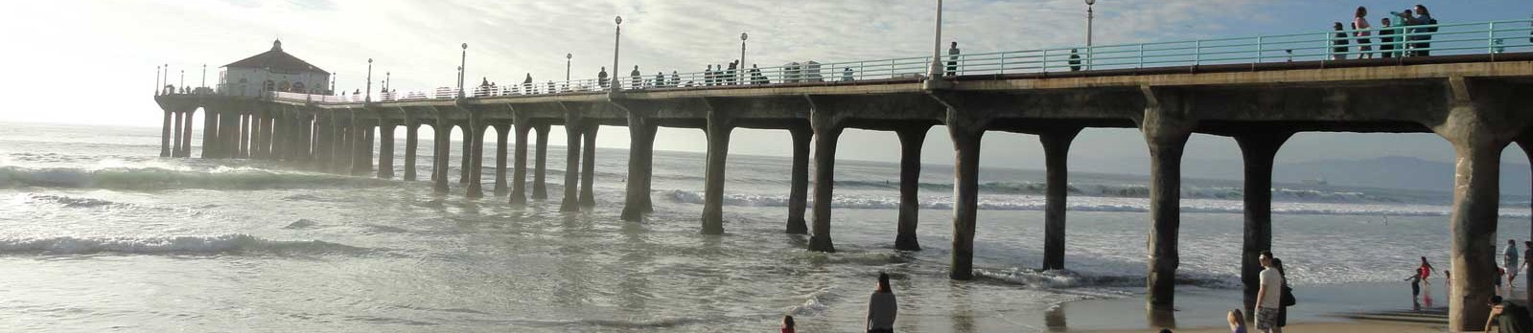
Pier Piling and Shore Life
Grade 4
Supplies
Student supplies:
- Field journal
- Pencil
- Plastic box
- Forceps
- Pipette
- Magnifying glass
- Activity sheets

Tables contain:
- Live specimens from pier pilings in buckets/tubs
- Sorting trays
- Sea water in buckets
- Organism labels
- Plastic Petri dishes
- Plastic vial holders
- 1.5 ml Eppendorf vials (pre-numbered)
- Clipboards (3) with preprinted barcode specimen record sheets

Goals & Objectives
- Students will experience a beach environment and be able to consider the effects of rising sea levels
- Students will have a hands-on experience exploring local intertidal life
- Students will sort and identify live marine invertebrates from pier scrapings
- Students will learn about the diversity of intertidal life and feeding strategies in the high energy environment

Relevant Topics in Next Gen Science Standards
NRC Framework Elements:
- Earth and Space Sciences
ESS3: Earth and human activity
ESS3.D: Global climate change
Sea level rise will affect beach contours and near-shore roads.
- Life Sciences
LS1: From molecules to organisms: Structures and processes
LS1.C: Organization for matter and energy flow in organisms
Marine organisms show a range of feeding structures, reflecting a range of feeding strategies.

Activity Outline
- Welcome / Site Information / Overview of Activities [10 minutes]
- Introduce NHM personnel and the Museum, and go over basic logistics of the activity (where we’re going, how long the activity will last, etc.).
- Ask students to think of questions they would like to ask the scientists as the day goes on, and record those questions in their field notebooks (when they get the notebooks later).
- Split into two groups: Beach and Pier
(NOTE: groups will swap, so all students get both experiences)

Pier students [approx. 1 hour]
- Introduction to what the students will be doing and seeing on the pier. Watch research scientists in the water collecting pier piling specimens. Bring up buckets with pier scrapings for the students to see. [15 minutes]
- Explain that today we’re going to work with field research biologists (divers) to collect marine invertebrates from the pier pilings. What methods might be used to live on the pier pilings — it is a hard substrate in a high energy zone with strong wave action (e.g., byssal threads, glue-like secretions, suction via tube feet).
- Split students between the 3 sorting stations on the pier (approx. 10 students/table — allow teachers or chaperones to do the group assignments).
- Distribute field notebooks, pencils, plastic box (with forceps & pipette), and magnifying glasses and instruct students to put their name on the kits.
- Students sort animals from their pier scraping into labeled Petri dishes. [30 minutes]
  - Students learn to use morphological characteristics to identify marine invertebrates to an appropriate taxonomic level (determined on site, based on student experience) with the help of the Museum scientists.
  - Students learn how differences in animal feeding mechanisms allow for different feeding strategies (Life Sciences LS1.C). What kind of food is available to pier piling organisms (suspended, stuck to substrate, mobile prey, etc.)? What mouthparts or other feeding structures might you expect animals to use catch those food types (filters, jaws, piercing mouthparts, etc.)? What mouthparts do you see and how does that match your expectations about what you expected?
  - The students transfer some of the collected specimens to molecular tubes that are labelled for DNA barcoding back in the lab (basic organizational skills for science data collection). Explain that DNA barcoding uses chemical sequences unique to each animal species in order to identify the species of individual specimens, as long as that unique sequence (“DNA barcode”) is in a searchable reference library.
- Collect field notebooks, pencils, and plastic boxes (1st Pier group only, to be returned later).
- Students regroup and are escorted to the beach for the tide pool activity. [15 minutes]

Beach students [approx. 1 hour]
- Under close supervision, students make their way from the pier to the beach via the sidewalk on Pacific Coast Highway (ca. 600 ft) then on to the tide pools. [15 minutes]
- Explain that today we’re going explore the tide pools.
- Students will pick up any trash that is found on the beach while traversing to the tide pools (buckets are provided).
- During this walk, students will be asked about and instructed on sea level rise as a result of global climate change (Earth and Space Sciences ESS3.D). How will the higher water level affect the beach (narrowing due to level, erosion toward land)? How will the highway change over their lifetime (relocation, armoring, etc.).
- Arrive at tidepools and explore tidepool/intertidal life [30 minutes]
- Ask if anyone knows what tide pools are and if they’ve ever been to one before. What makes this area unique among life zones (intermittent air/water exposure and high energy)? Expand with a brief, non-detailed explanation of ocean tides and the high energy of wave action on the tide pools. What might be necessary attributes to live there (suction, adhesion, resilience, hard shells)? What sorts of attachment strategies do you see?
- A goal is to find and examine as many different kinds of organisms as we can and describe what allows them to live in the intertidal. To do this, we are going to work in teams to gently explore the pools, look in the seaweed and look under rocks for any animals present and take an inventory. Demonstrate how to responsibly explore the tide pools (e.g., always replacing rocks after looking underneath so that organisms will survive).
- Students regroup and are escorted safely back to the pier for sorting activities. [15 minutes]

- All students reconvene following parallel Pier and Beach activities
- Reconvene at the pier; return field notebooks, pencils, and plastic boxes to students from Pier Group 1; and break students up into 6 groups (approximately 10 students each).
- Begin lunch.
- Pose questions to the scientists (6 scientists, 1 per group of students). [approx. 30 minutes]
- Hand out post-event activity sheets as students gather to get back onto the bus.
- Pack up and load students on the bus.

